Solubility Rules and Nomenclature

## Objectives

By the end of this lab activity, you will be able to:

1. Define *precipitate*, *double replacement*, and *spectator ion*.
2. Write molecular, ionic, and net ionic equations.
3. Identify when double replacement reactions occur.
4. Use correct nomenclature when describing chemical reactions.
5. Identify patterns in solubility for certain elements and work with your group to define solubility rules.

**Background**

Writing Chemical Equations

What do the stalagmites and stalactites found in caves have in common with the hard water stains in your sink? Both of these are the result of **precipitation**, or the formation of solids when two solutions are combined. When ions of opposite charges near each other, they have the potential to interact. If the interaction between the two ions is stronger than the interaction between the ion and water, a precipitate will form.

When two different **aqueous** solutions, where water is the **solvent**, are mixed and a precipitate is formed, a **double replacement reaction** has taken place yielding an insoluble product. The reaction of aqueous solutions of calcium chloride and zinc sulfate, for example, combines Ca2+ ions and SO42- ions in a concentration above the saturation point of calcium sulfate. The formation of the precipitate is described by the following equation:

CaCl2(aq) + ZnSO4(aq) 🡪 ZnCl2(aq) + CaSO4(s) (1)

The reaction in equation 1 is written as a **molecular equation**, depicting the reactants as compounds dissolved in water (the *aq* denotes **aqueous** and means the salts are dissolved in water). The *s* stands for solid, indicating that a precipitate has formed.

When compounds like calcium chloride and zinc sulfate are dissolved in water, the two ions do not stay together. Rather, they **dissociate** (separate) and are free to interact with water molecules (Figure 1). An **ionic equation** can be used to illustrate the nature of the ions in solution:

                 Ba2+(aq) + 2OH–(aq) + 2Na+(aq) + SO42–(aq)  🡪 BaSO4(s) + 2Na+(aq) + 2OH–(aq) (2)

The ionic equation tells us more information and is a more accurate description of what is happening during the reaction. However, it can be quite cumbersome to write out each individual ion in solution.

Removing the sodium and hydroxide ions from Equation 2 yields Equation 3, a much more simplified expression called the **net ionic equation**. The sodium and hydroxide ions are not participating in the overall reaction and are referred to as **spectator ions**, and are thus excluded from the net ionic equation:

Ba2+(aq) + SO42–(aq)  🡪 BaSO4(s) (3)

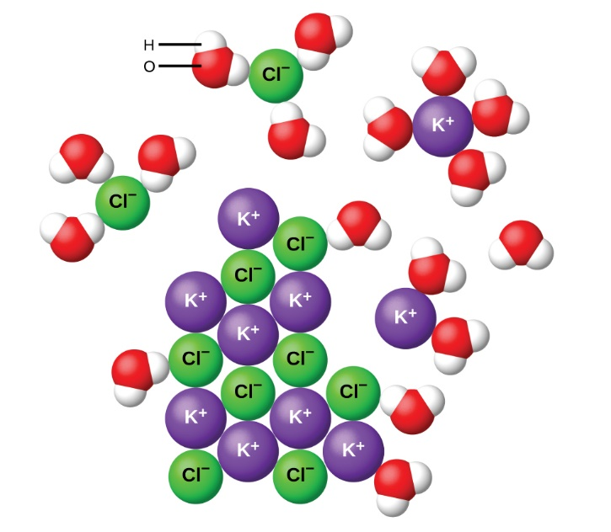

**Figure 1.** The dissociation of potassium chloride in water. The potassium ions (purple) interact with the oxygen atoms (red) in the water molecules, while the chloride ions (green) interact with the hydrogen atoms (white) in the water molecules. (Image credit: *BC Open Textbooks*).

Nomenclature

There are over 10 million known chemical substances and this list continues to grow. It’s not reasonable to expect everyone to memorize every chemical name, and yet we must have a way to communicate with each other about these substances. In ancient times pure elemental substances were named using Greek, Latin, Arabic, or Persian word roots that described certain characteristics. Now, elements are assigned **chemical symbols**, one or two letter notations representing an atom of a specific element. Some atomic symbols have been chosen based on their ancient names. For example, the atomic symbol for copper is Cu, from the Latin word cuprum, which describes the reddish color of this metal. The atomic symbol for mercury is Hg, from the Latin word hydrargyrum, meaning quicksilver.

When a single letter is used for the chemical symbol, like *S* for sulfur, we write the symbol with a capital letter. When the chemical symbol has two letters, as in *Si* for silicon, we capitalize the first letter and use lower case for the second letter.

Naming compounds which are composed of more than one type of atom is more complicated. Over the past 150 years, chemists have refined their methods of naming chemical compounds with guidelines for chemical **nomenclature** based on the categorization of substances. These rules of nomenclature are determined by an organization called The International Union of Pure and Applied Chemistry or **IUPAC** for short (we say this like “eye-you-pack”). In this laboratory exercise, you will practice naming the compounds you use to perform double replacement reactions.

*Ionic Compounds*

When an ionic compound is composed of two elements, a metal and a nonmetal, we call this a **binary ionic compound**. The name is simply the name of the cation (the metal) followed by the name of the anion, which ends in *-ide*. **Polyatomic ions** consist of an ion where the atoms are held together by covalent bonds, and the charge is distributed across the entire ion (e.g., PO43-). These are also named with the cation first, followed by the anion. However, the polyatomic ions have specific names as well!

*Metals with Variable Charges*

As we move down the periodic table and encounter elements with d-orbitals, we find that there are some metals that have multiple stable configurations, which allows them to form cations of different charges (Figure 2). When writing the names of compounds where the cation comes from groups 1A or 2A, like sodium chloride, there is no need to indicate the charge on the cation – we know that sodium always forms an Na+ ion. What about something like copper chloride? Is the compound CuCl or CuCl2? In cases like these, the charge of the metal ion is included as a Roman numeral in parentheses immediately following the metal name. These two compounds are then unambiguously named copper (I) chloride and copper (II) chloride, respectively.

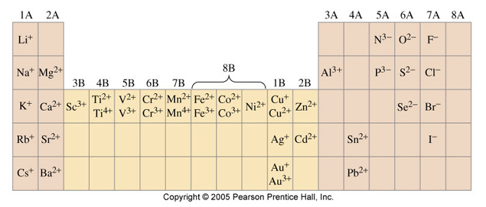

**Figure 2.** Monatomic cations of various elements. Groups 1A, 2A, and a small subset of other metals form cations of only one charge. Other transition metals, beginning in group 4B can form two or more cations of different charges (Image Source: *Pearson*).

There are other rules for naming covalent compounds, but they are beyond the scope of this laboratory exercise.

## Experiment

Safety

* Wear long pants that cover the ankles, closed-toe/-heel shoes, and a shirt that covers the shoulders and entire toros. If we see skin, we will not let you in!
* Wear goggles and lab coat when working with any chemicals
* Some of these metals can be dangerous if ingested. Gloves will be provided, and you should wash your hands thoroughly upon entering and exiting the laboratory.
* Dispose of all waste in the designated containers.

Part 1: Solubility and Displacement Reactions

1. Obtain a colored paper sheet and overhead sheet from your instructor. The paper will list the compounds you will be responsible for testing.
2. Obtain a set of chemicals in dropper bottles that match the compounds on the paper from step 1.
3. Lay your paper sheet on a clean, dry section of your lab bench. Lay the overhead sheet over the top.
4. Carefully add one drop of each solution where it is indicated on the grid. When you have finished, you will have two drops of solution in each square and you will have mixed all possible combinations of solutions in the set.
5. In your lab notebook, copy the grid for your paper and indicate which reactions produced a precipitate.
6. Write net ionic equations for each reaction that produced a precipitate. You may wish to start with an ionic equation if you have trouble identifying the spectator ions, but this isn’t necessary.
7. Balance the net ionic equations if necessary.
8. Wipe the overhead sheet with a Kimwipe or paper towel and dispose of it in the designated waste container, NOT the trash. (Metals are toxic in the environment!)
9. Repeat the procedure for the next set of your assigned solutions.
10. Obtain a master grid from your instructor. This contains all of the solutions tested by everyone in the lab. Work with your lab bench mates to fill out the rest of table (you will only have done a subset of reactions). Once you have filled out the entire solubility chart, work with your group to define some solubility rules. You may have heard some before, but don’t look them up immediately; rather, work together to define solubility rules that make sense to the entire group.

Part 2: Nomenclature

1. In your lab notebook, write out the IUPAC names for the compounds you used in Part 1. You should have a name written for each compound you used in Step 4.
2. Write out the IUPAC names for any precipitates that formed.
3. Check your work with your group.